PantryPal User Tutorial
By Aldo Medina
4/19/2026
Use within your own means

This tutorial explains how to use PantryPal to search for recipes based on ingredients, save favorite recipes, and manage saved content. The application was designed to be simple and user-friendly across desktop and mobile devices.
Step 1: Open the PantryPal homepage.
Step 2: Enter a list of ingredients separated by commas.
Example:
chicken, rice, garlic
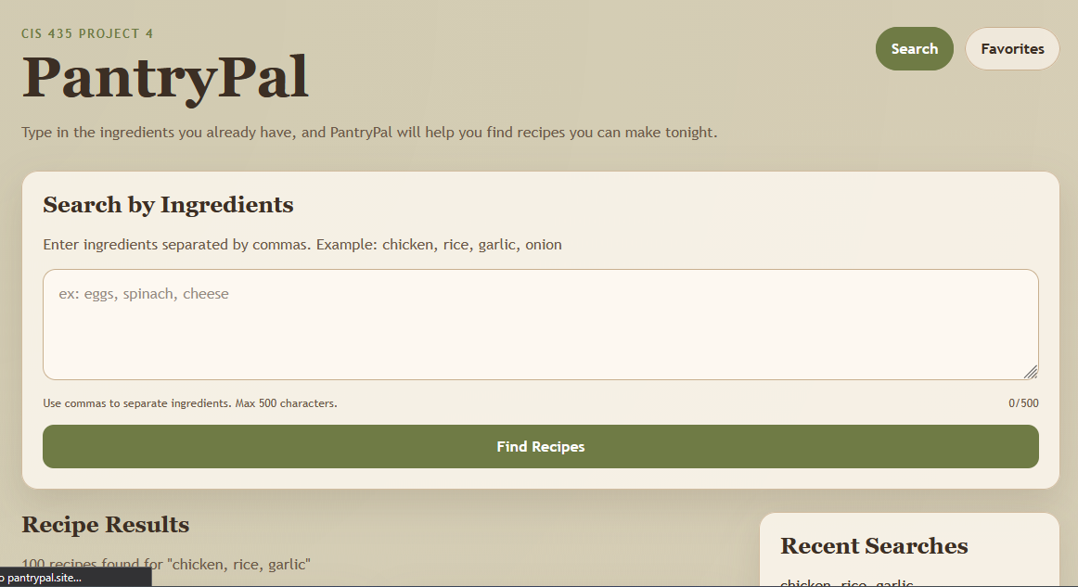
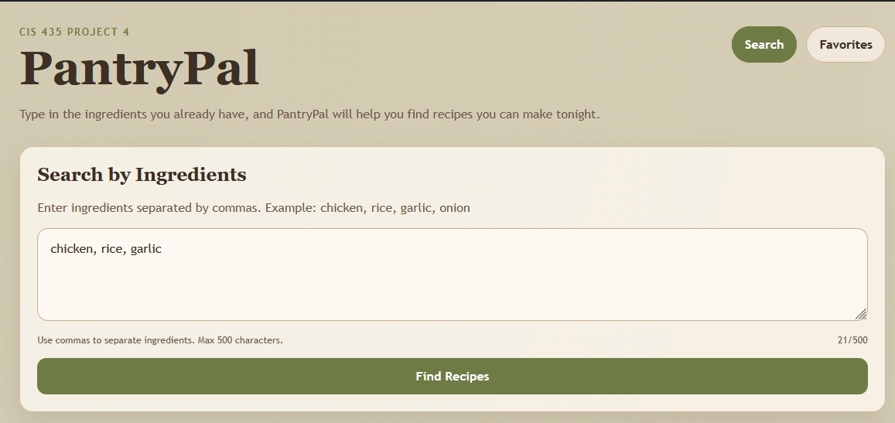

Step 3: Click "Find Recipes".
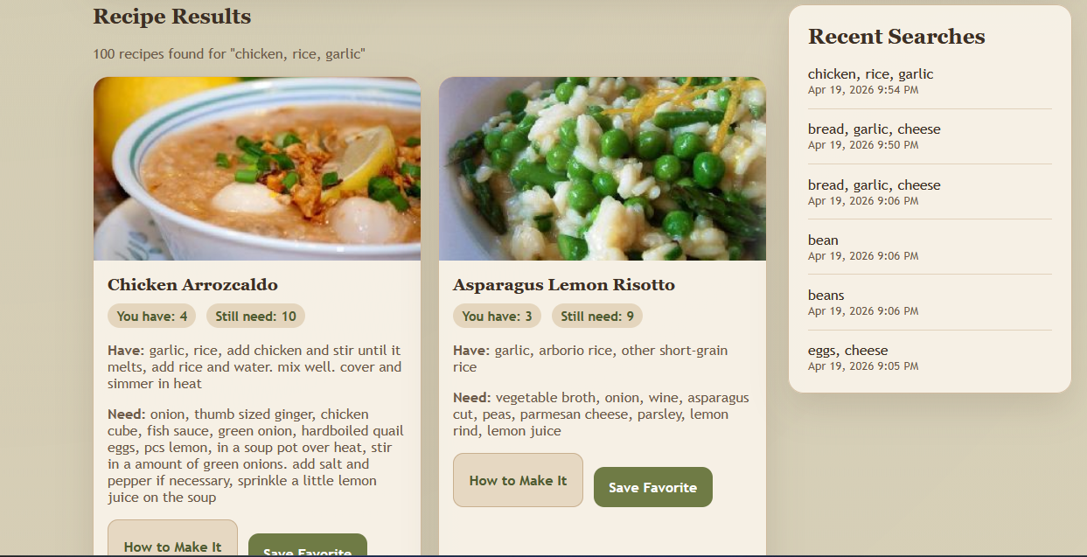

The system will validate the input and display matching recipes, the limit of recipes displayed is 100!

Step: 4
Each recipe card displays:
- recipe title
- image
- number of used ingredients
- number of missing ingredients
Users can browse multiple results and select recipes of interest.
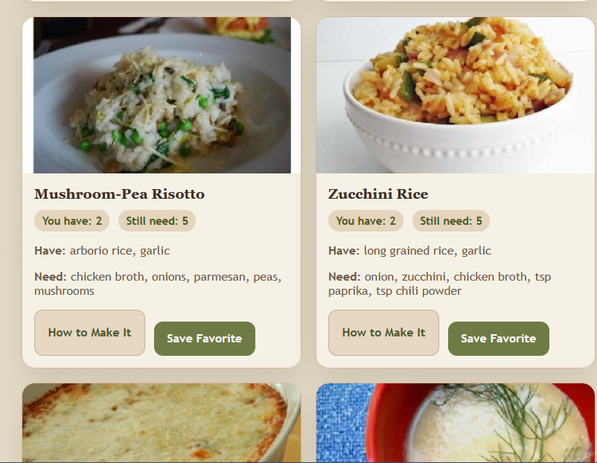

Step 5: Click the "Save Recipe" button on a recipe card.
Step 6: The recipe is stored in the database and can be accessed later.
Step 7: Click "View Favorites".
Step 8: The saved recipes page displays all previously saved recipes.
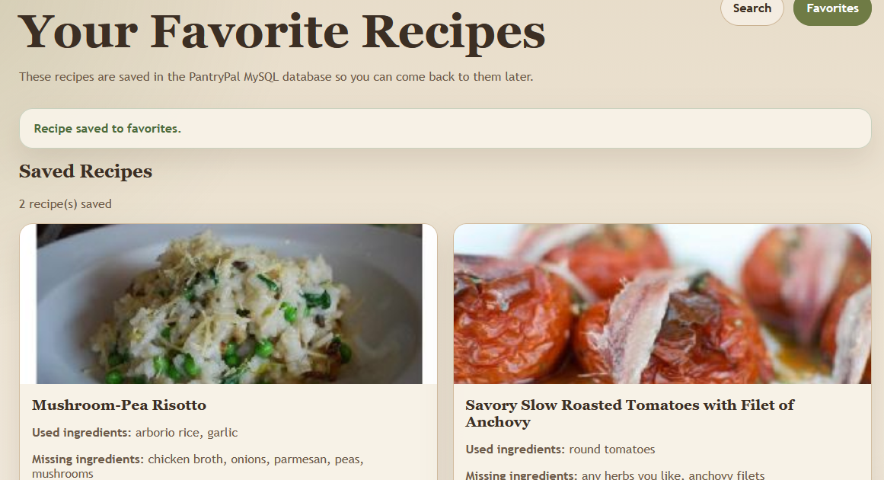

Step 9:
Users can click "How to make it" to see:
- full ingredient list
- step-by-step instructions
- and the full recipe from Spoonacular
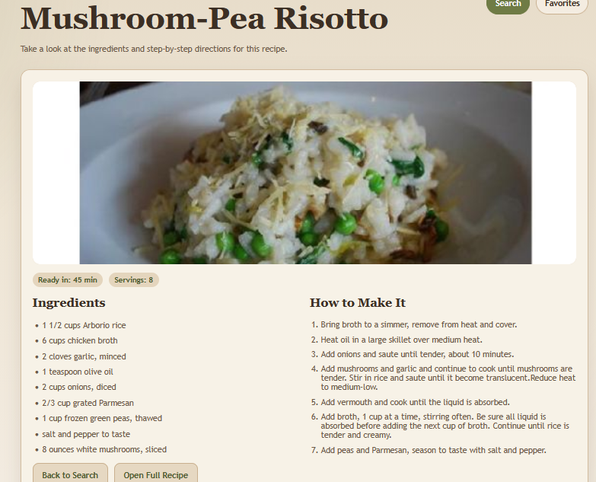

Step:10
Users can add personal notes to saved recipes for future reference.
Example:
"This recipe needs more seasoning."
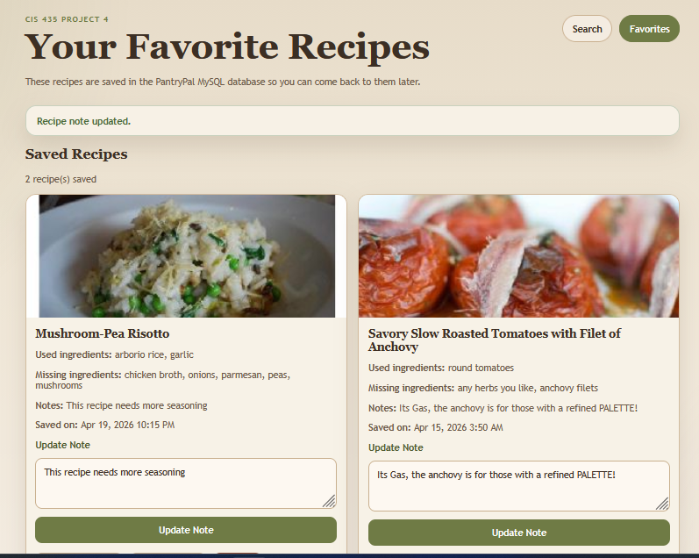

Step: 11
If the user submits an empty input, the system displays a validation error message.
This ensures proper input handling and improves user experience.
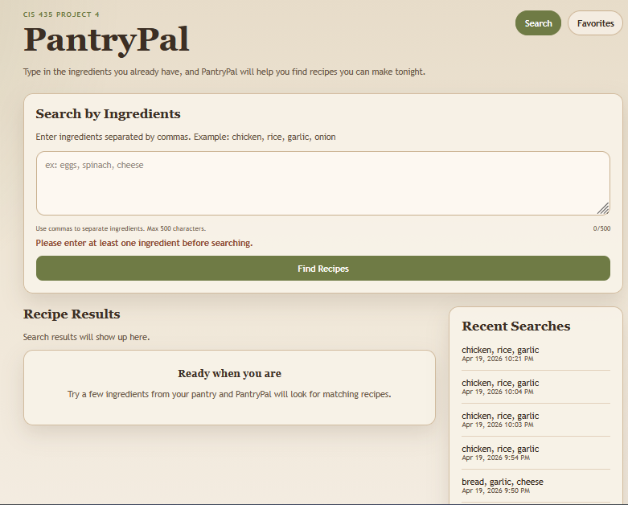

Step: 12
LAST but not LEAST PantryPal is responsive and works on different screen sizes, including mobile devices.
